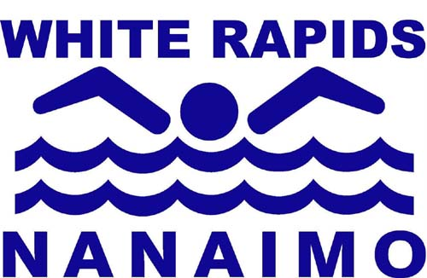
NANAIMO, BOWEN PARK
KIN OUTDOOR POOL

Pool Manager:

Job Posting Date: Friday November 21 , 2014
Job closing Date: Friday December 5, 2014

- This position reports to the Nanaimo White Rapids Swim Club ( NWRSC ) Pool Operations Committee.

- The term of the position is Jan 1 – Dec 31
  - The full time work is expected May 1st to August 31st
  - The part-time distance work is September – April

- The location of the full time work is the Bowen Park Kin Pool.

- The salary for this position is $13,000.00 per year – with bonus opportunities

- The Manager/Supervisor will undertake the following duties:

  - Manage the physical plant operations, maintenance, staff training and scheduling during the period of the Co-Management Agreement during the summer season.
  - Be familiar with the Co-Management Agreement and implement the items that are the responsibility of the NWRSC Pool Operations.
  - Meet with the NWRSC Pool Operations Committee to participate as an ex-officio, non-voting member of that management committee.
  - Ensure that the Bowen Park Kin Pool is compliant with the statutory regulations in place (currently the Swimming Pool and Stray Pool Health Act)
  - Ensure that the Bowen Park Kin Pool is compliant with the facilities operational insurance contract.
  - Liaise with the City of Nanaimo and their appointed representatives to facilitate the physical plant operations of the Bowen Park Kin Pool, and maximize the benefits from a good relationship between the Co-Management parties.
  - Create and maintain facility and staff records in accordance with regulations, and standards of practice for aquatic facilities.
  - Create reports for routine operational issues, incidents and issues requested by the Pool Operations Committee and/or the City of Nanaimo.
  - Effectively transfer staff scheduling, income and expense issues to the appointed bookkeeper as required to maintain payroll and current account payments.
  - Assist in creating, implementing and reporting on the annual Bowen Park Kin Pool Budget.
  - Maintaining janitorial supplies, safety equipment and operational equipment in good order and placement.
  - Maintain the focus on safe, effective operations of the Bowen Park Kin Pool.
  - Liaise with the NWRSC Coaching Staff as needed to ensure safe and effective operations.

  - Create and maintain scheduling and booking processes for the facility.

    - Some of this task will be undertaken during the non-operational season of September- April each year. as negotiated or contracted to others, by the manager and the pool operations committee Management and implementation of user group and rental contracts
    - Participating in the facility rental program to determine the rates, contract content, collecting the payments and reporting as needed.
    - Create and manage the school and community lesson programs.
    - Will act in the capacity of a lifeguard and instructor in addition to the manager/supervisory duties as needed. The management and supervisory duties are part but not all of duties of this position.

The Facility Manager/Supervisor has the authority to:

- Communicate information about staffing issues to staff as per decisions and discussions with the Pool Operations Committee to make decisions about opening and closing the facility
- ensure the facility is safe at all times
- authorize purchase of facility supplies and equipment within the agreed budget
- alter and adjust contract use contract and conditions as needed to maintain safe and effective facility operations.
- Communicate on behalf of the Pool Operations Committee when appropriate

All applicants should email a covering letter and resume to Russ Der, at nanaimowhiterapids@gmail.com.

The closing date for applications is Friday December 5, 2014

